Research Experiences at NSF-Funded Startups & Small Businesses

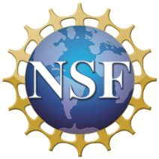
The National Science Foundation (NSF) is an independent federal agency created by Congress in 1950 "to promote the progress of science; to advance the national health, prosperity, and welfare; to secure the national defense…" With an annual budget of $7.2 billion (FY 2014), we are the funding source for approximately 24 percent of all federally supported basic research conducted by America's colleges and universities. In many fields such as mathematics, computer science and the social sciences, NSF is the major source of federal backing.
About the National Science Foundation’s Small Business Program
At NSF, Small Business Innovation Research/Small Business Technology Transfer (SBIR/STTR) is an approximately $160 million program that catalyzes the commercialization of high-risk technological innovations via research and development grants to small businesses and startups. Phase II SBIR/STTR grantees receive $750K over a two year period. (nsf.gov/eng/iip/sbir/index.jsp)
Research Experiences for Undergraduates (REU), High School Students (RAHSS), Teachers (RET), & Veterans (VRS)
NSF’s REU, RAHSS, RET, and VRS supplemental funding through SBIR/STTR supports active participation in science, engineering, and education research by students, teachers, community college faculty, and veterans in an entrepreneurial setting. These supplement programs seek to expand student/teacher/veteran participation in all kinds of research—both disciplinary and interdisciplinary. They draw on the integration of research and education to attract a diverse talent pool into careers in science and engineering. (nsf.gov/eng/iip/sbir/portfolio/researchexp.jsp; email: SBIRresearchexp@nsf.gov).

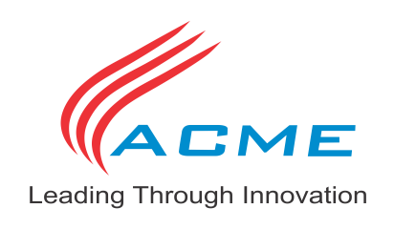
During the [Spring semester of 2015, ACME INDUSTRIES,] an active NSF SBIR/STTR Phase II grantee, is looking for [a(n) undergrad, teacher, CC faculty, veteran] to participate in the [REU/RAHSS/RET/VRS] program. All research will be done at the [Springfield, Missouri] facility.

[ACME INDUSTRIES (www.acme-industries.com; 4567 Wilson Blvd, Arlington, VA 99999)]
[GENERAL COMPANY DESCRIPTION HERE XXXXXXXXXXXXXXXXXXXXXXXXXXXXXXXXXXXXXXXXXXXXXXXX XXXXXXXXXXXXXXXXXXXXXXXXXXXXXXXXXXXXXXXXXXXXXXXXXXXXXXXXXXXXXXXXXXXXXXXXXXXXXXXXXXXXXXXXXXXXXXXXXXXXXXXXXXXXXXXXXXXXXXXXXXXXXXXXXXXXXXXXXXXXXXXXXXXXXXXXXXXXXXXXXXX]

We are looking for a [student/teacher/cc faculty/veteran] meeting the following criteria:
- [Section with specific requirements (e.g. a JR/SR in EE with at least a 2.5 gpa)
- Must be able to lift 25#; etc. Must attend any of the following (local) univ/colleges, etc.
- RAHSS students must reside within a 20 mi radius of the company.]

The selected [student/teacher/cc faculty/veteran will conduct the following research activities..XXXXXX
XXXXXXXXXXXXXXXXXXXXXXXXXXXXXXXXXXXXXXXXXXXXXXXXXXXXXXXXXXXXXXXXXXXXXXXXXXXXXXXXXX.]

We will accept applications through [December 31, 2014]. Please email a 1 page resume and 1 page letter of interest with your contact information to [SPRING-REU@acme-indstries.com].

